*//Create a list of tuples, where the 1st element of  
// the tuple is an int and the second element is a string.*

*// problem 1  
//print the numbers where the corresponding string length is 4*

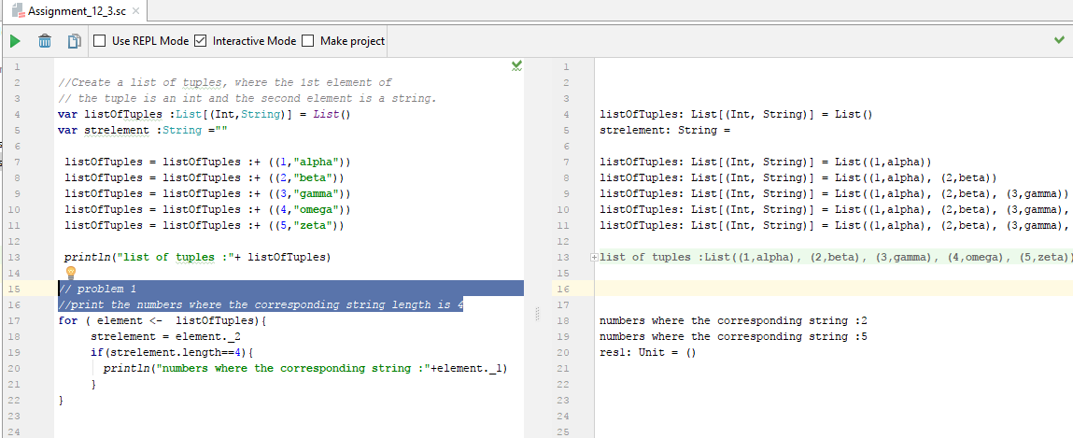

Problem 2

*//find the average of all numbers, where the corresponding string contains  
// alphabet ‘m’ or alphabet ‘z’*

